**46.3. Maven Key Concepts**

**Maven Key Concepts**:

* POM File - pom.xml
* Project Coordinates

**POM File - pom.xml**:

* Project Object Model file: POM file
* Configuration file for your project
  + Basically our “shopping list” for Maven
* Located in the root of our Maven project

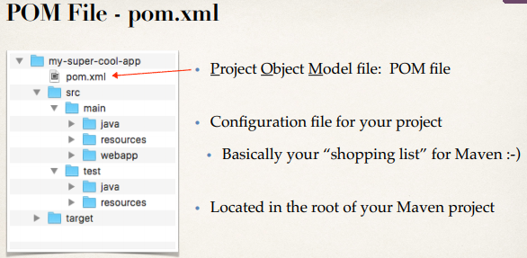

**POM File Structure**:

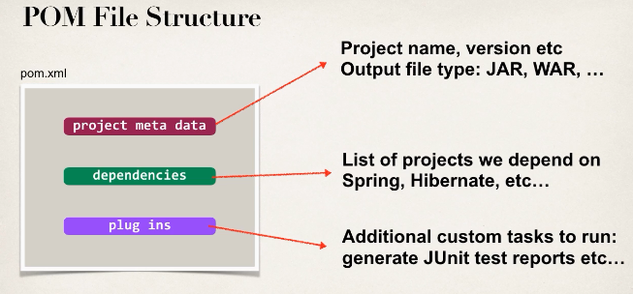

**Simple POM File**:

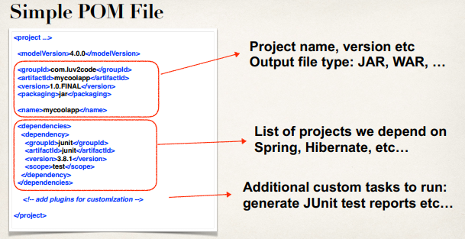

**Project Coordinates**:

* Project Coordinates uniquely identify a project
  + Similar to GPS coordinates for our house: latitude / longitude
  + Precise information for finding our house (city, street, house #)

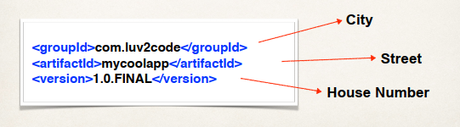

**Project Coordinates – Elements**:

|  |  |
| --- | --- |
| Name | Description |
| Group ID | Name of company, group, or organization.  Convention is to use reverse domain name: **com.luv2code** |
| Artifact ID | Name for this project: **mycoolapp** |
| Version | A specific release version like **1.0, 1.6, 2.0**  If project is under active development then  **1.0-SNAPSHOT** |

**Project Coordinates – Elements – Example**:

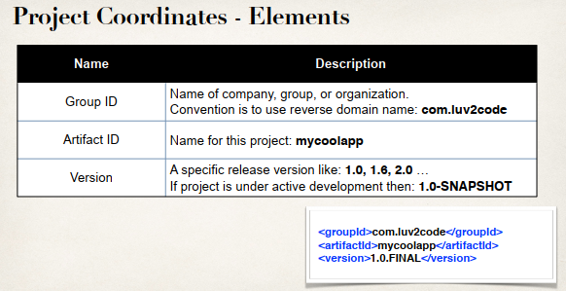

**Example of Project Coordinates**:

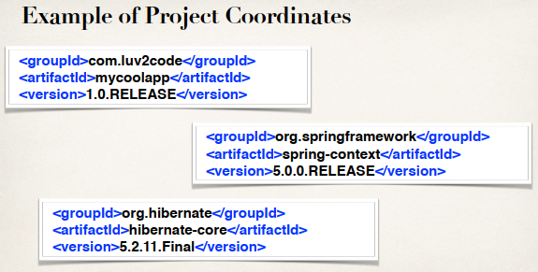

**Adding Dependencies**:

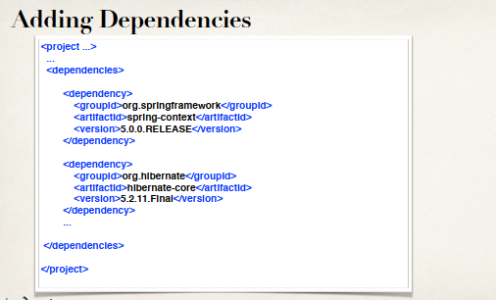

**Dependency Coordinates**:

* To add given dependency project, we need
  + Group ID, Artifact ID
  + Version is optional …
  + Best practice is to include the version (repeatable builds)
* May see this referred to as: GAV
  + Group ID, Artifact ID and Version

**How to Find Dependency Coordinates**:

**Option 1**: Visit the project page (spring.io, hibernate.org etc.)

**Option 2**: Visit <http://search.maven.org> (easiest approach)